**ANALYSING HOUSING PRICES IN METROPOLITAN AREAS IN INDIA .**

1. **INTRODUCTION**:

1.1 Over view

House price prediction in a metropolitan city in India is a valuable solution for potential home buyers, real estate agents, and investors. By leveraging historical sales data, property details, and location-specific information, a predictive model can accurately estimate house prices. The model's scalability, real-time updates, user-friendly interface, and transparency ensure it meets the needs of stakeholders. Integration capability, data privacy, and cost- effectiveness are also important considerations. By addressing these requirements, the prediction model provides reliable insights, empowering stakeholders to make informed decisions in the fast-paced real estate market.

1.2 Purpose

Prediction house prices are expected to help people who plan to buy a house so they can know the price range in the future, then they can plan their finance well. In addition, house price predictions are also beneficial for property investors to know the trend of housing prices in a certain location.

1. **PROBLEM DEFINITION AND DESIGN THINKING**:

* Empathy Map.

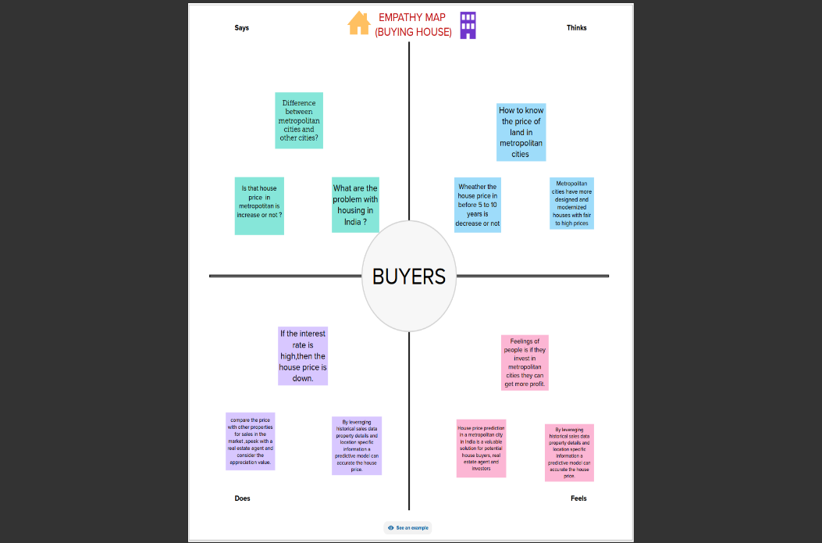

* Ideation and Brainstroming Map

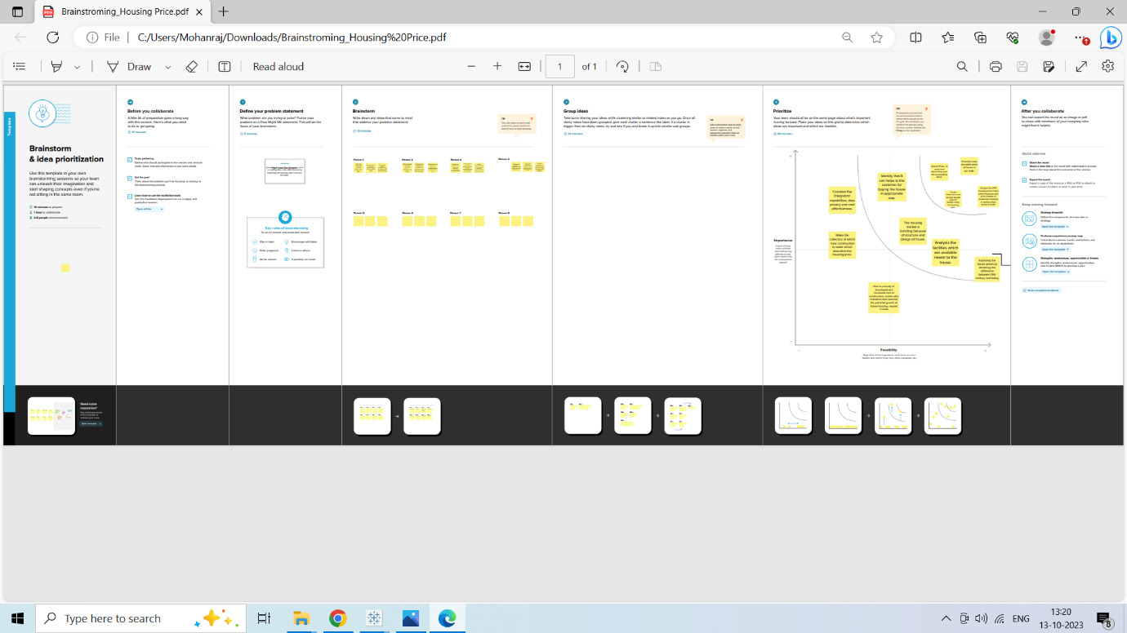

1. RESULT:

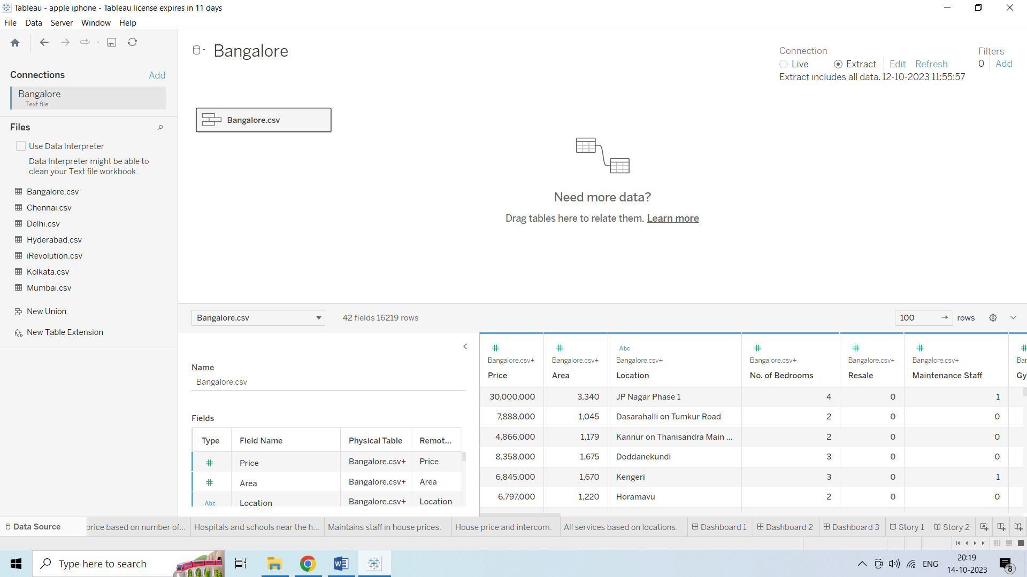

* Number of houses based on area in sqf

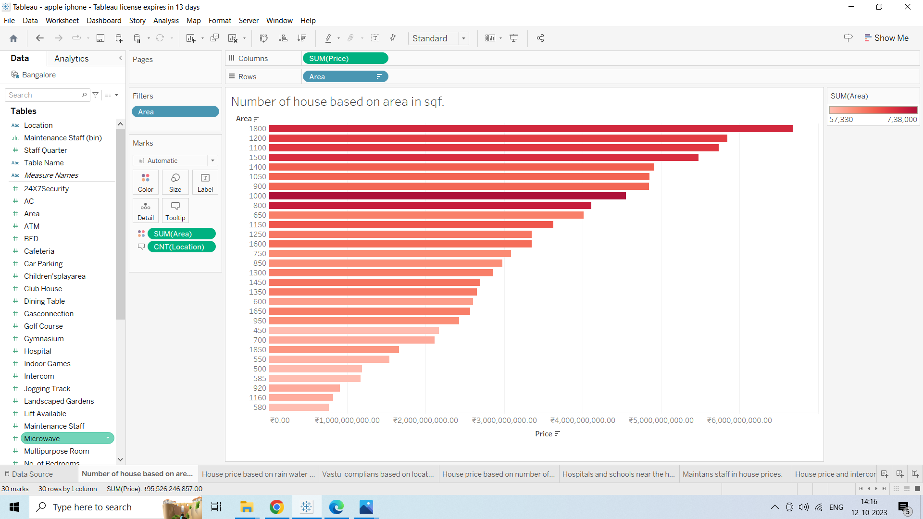

* House price based on rain water pits

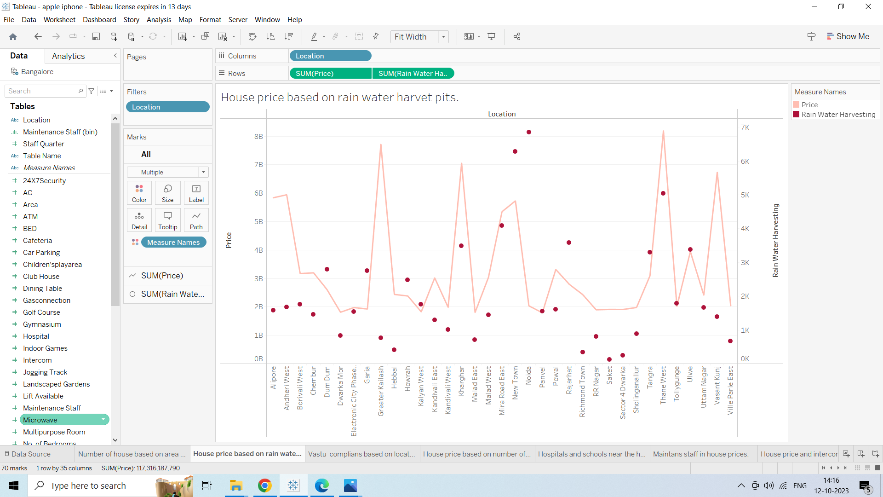

* Vastu complaints based on location

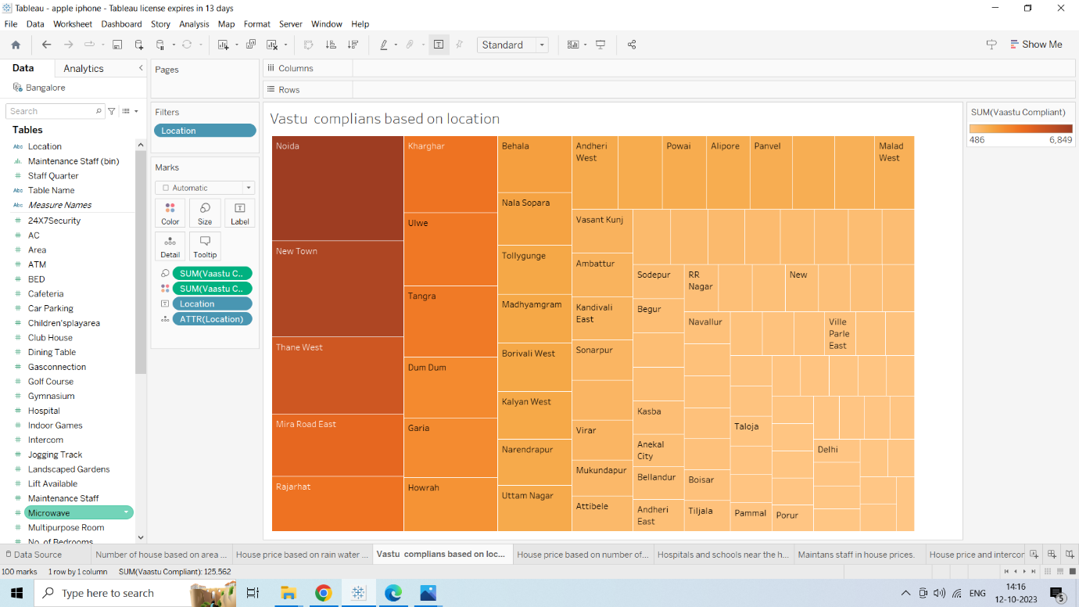

* House price based on number of Bedrooms

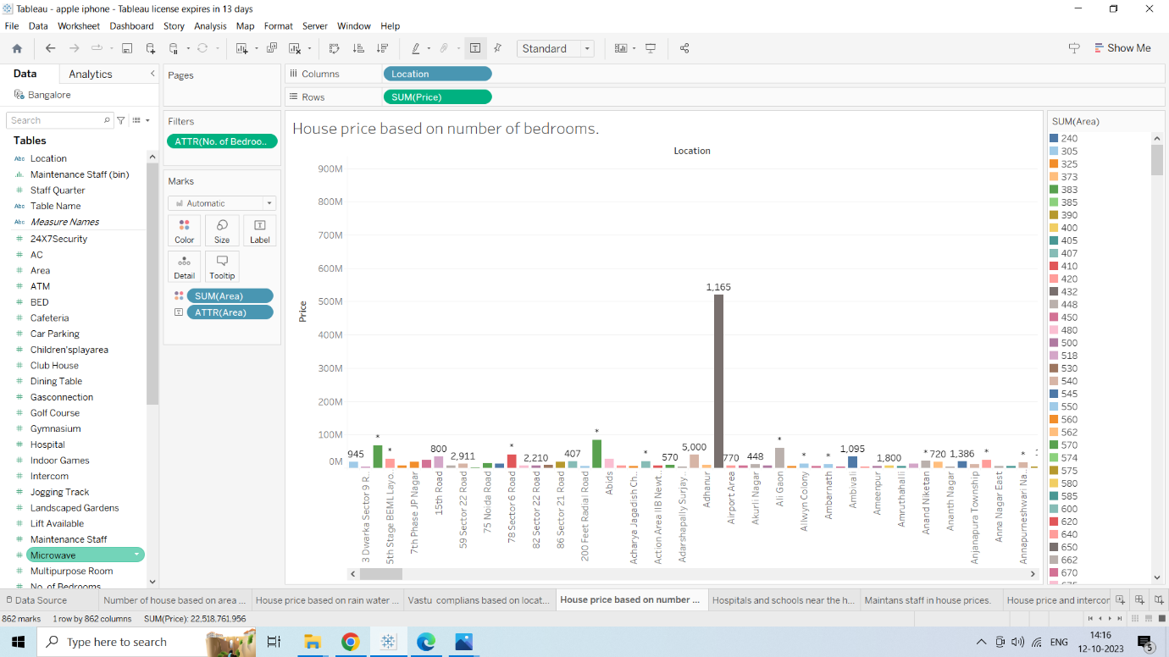

* Hospitals and Schools near the houses

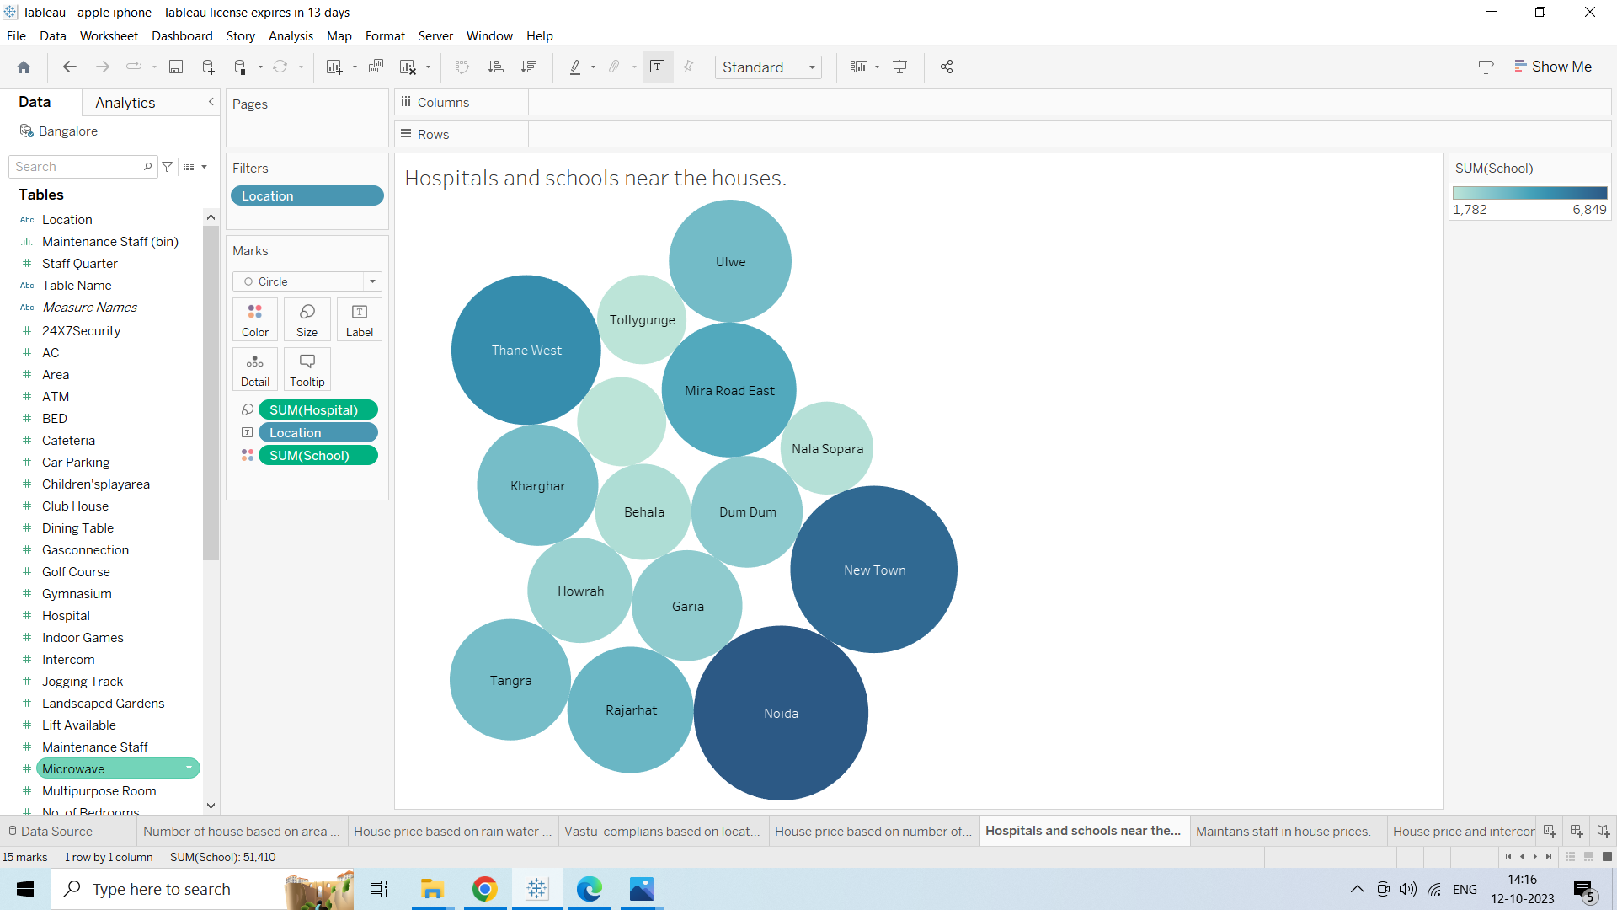

* Maintains staff in house prices

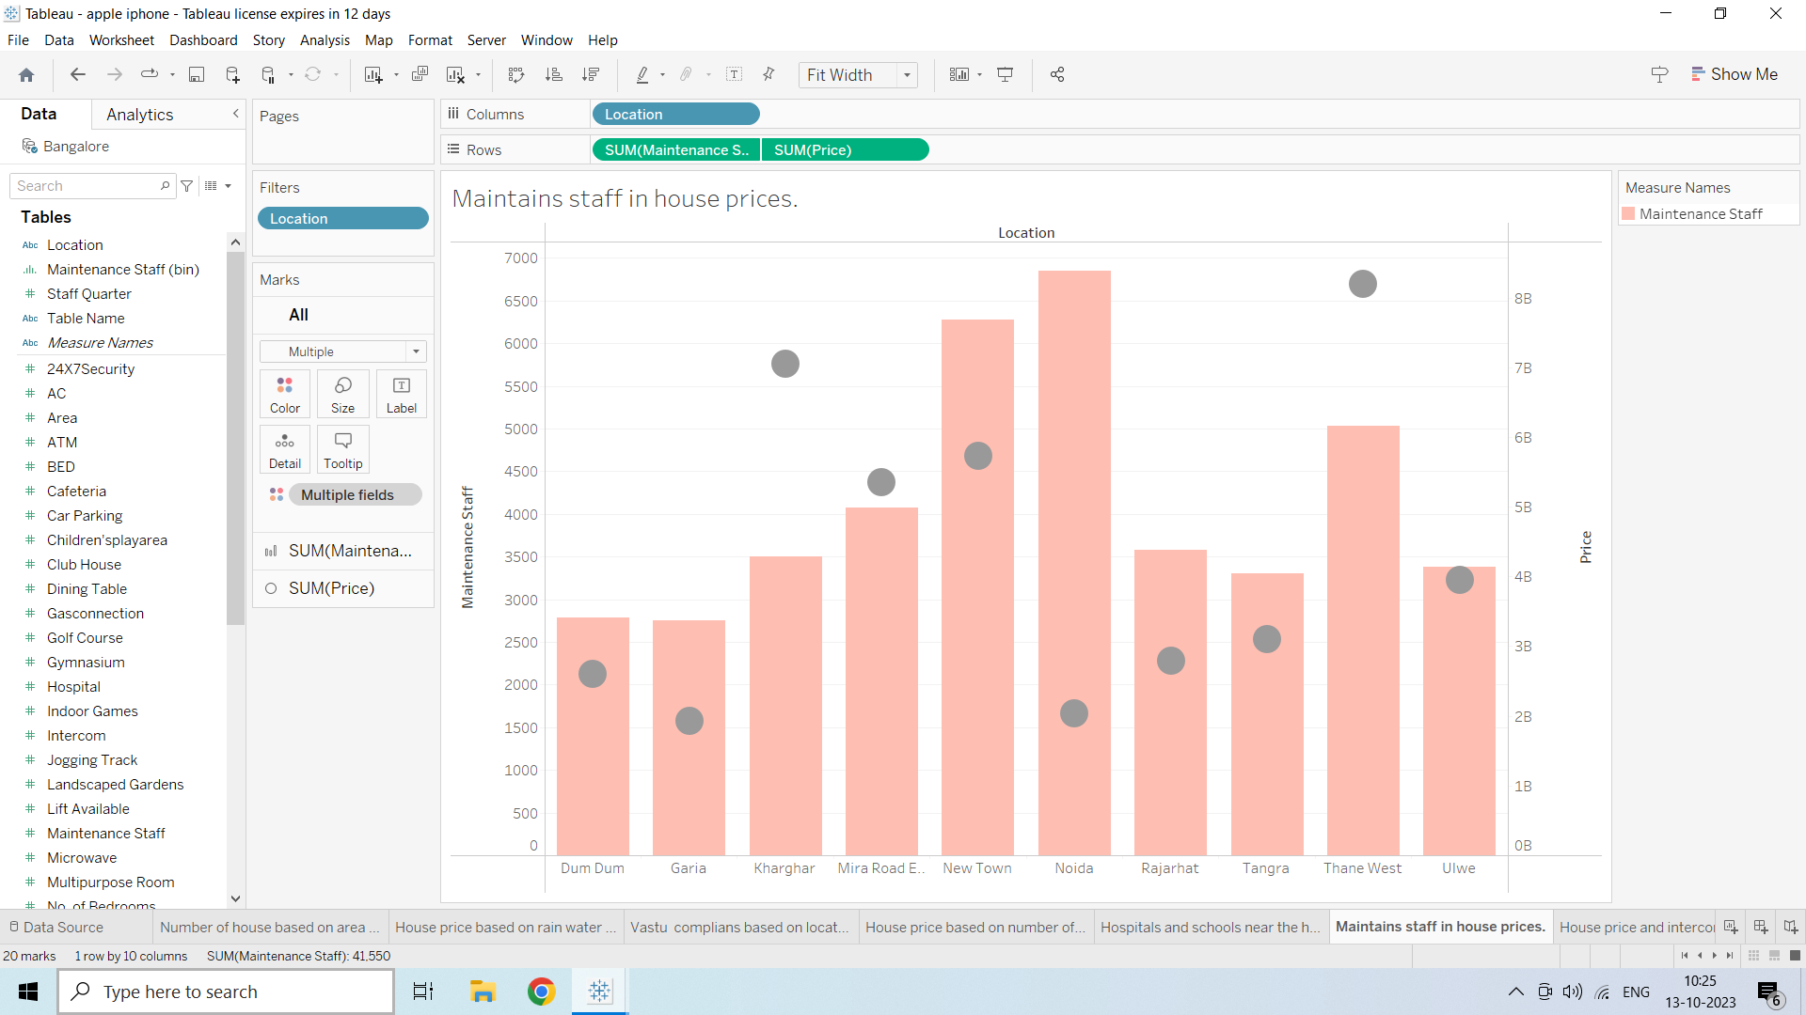

* House price and intercom

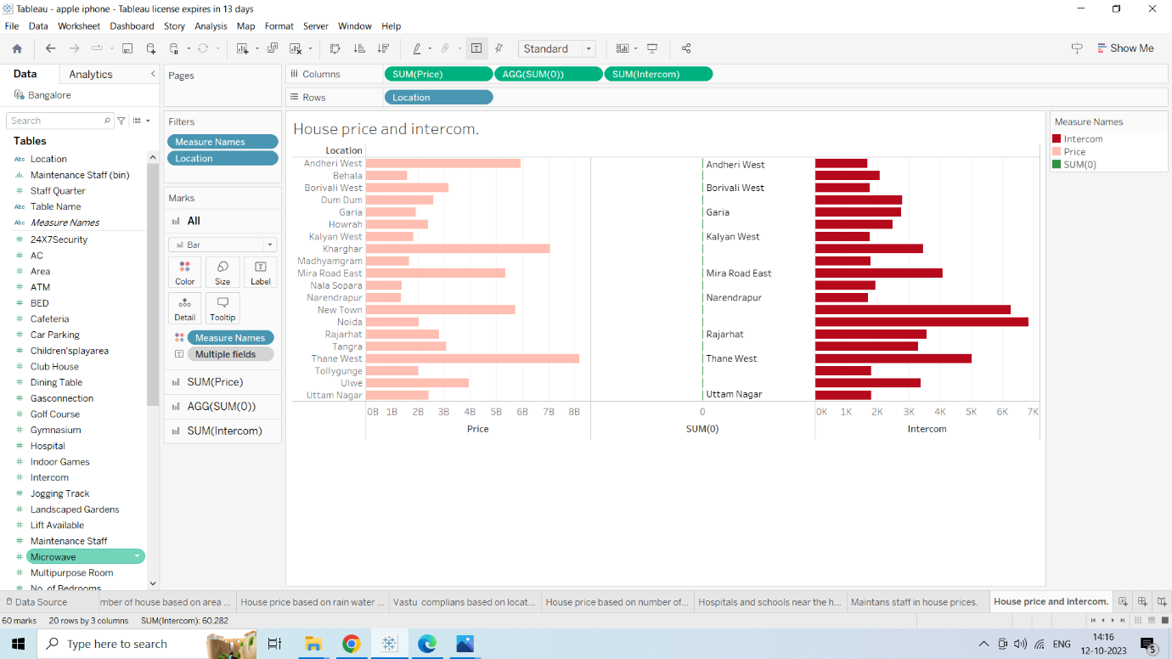

* All services based on locations

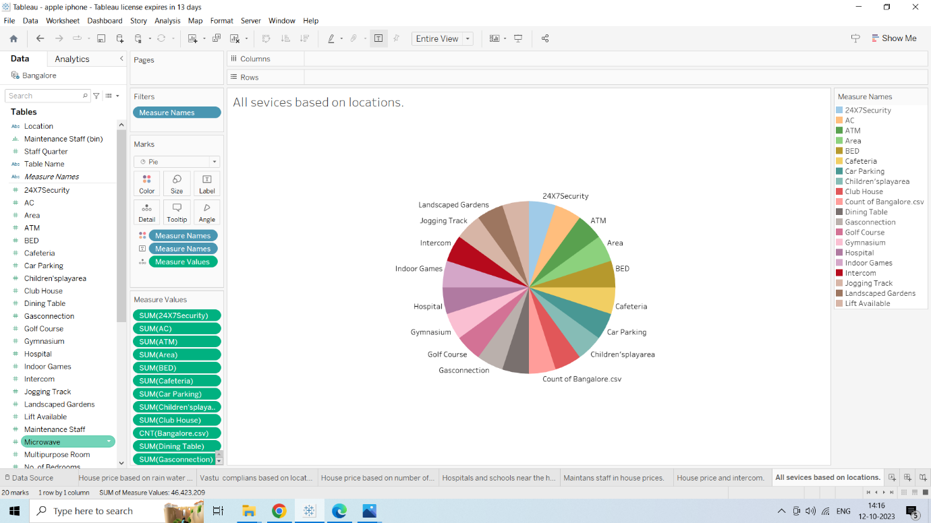

**Dashboard 1**

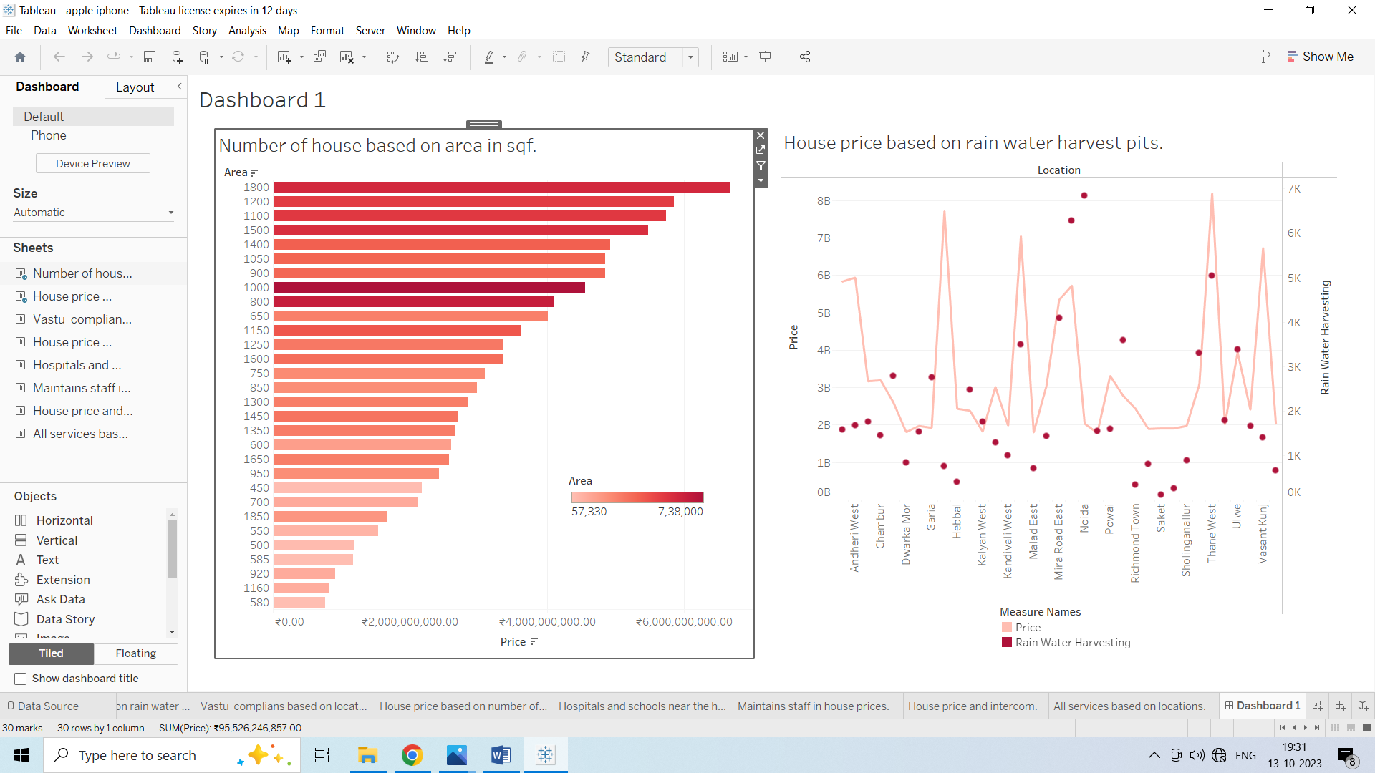

**Dashboard 2**

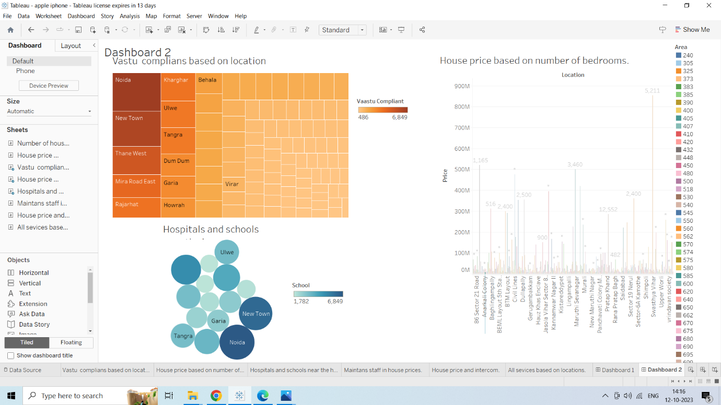

**Dashboard 3**

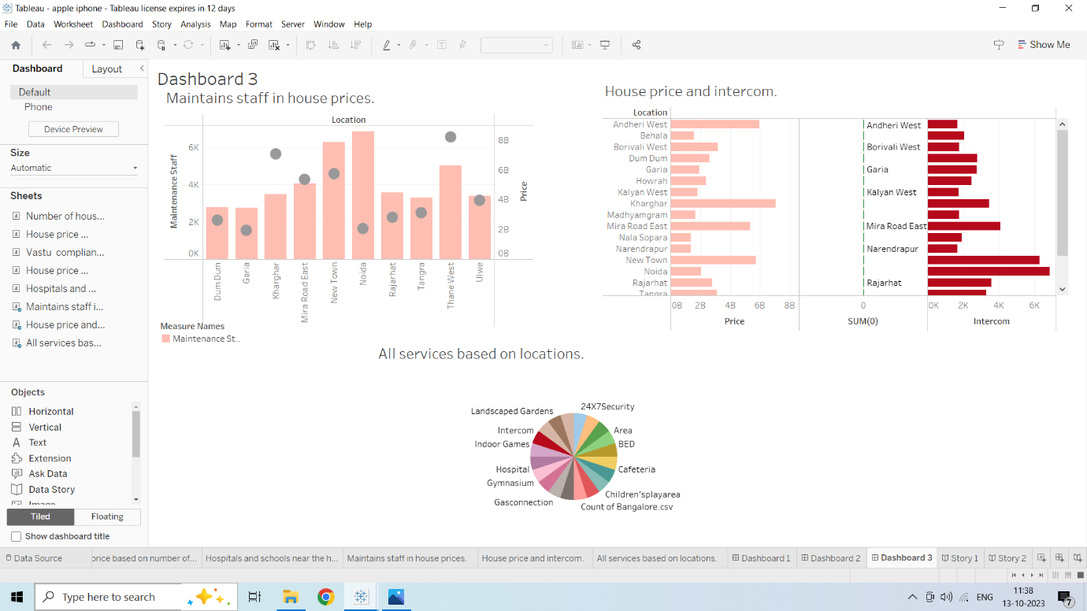

**Story 1**

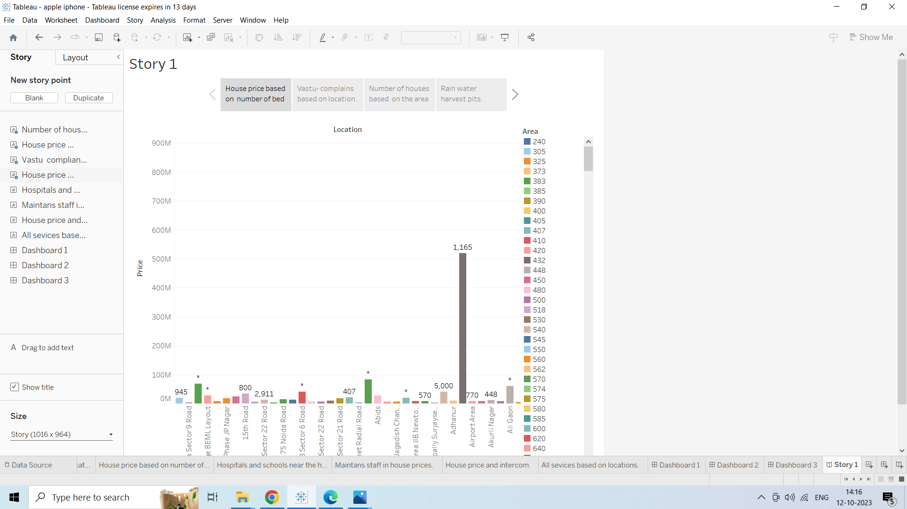

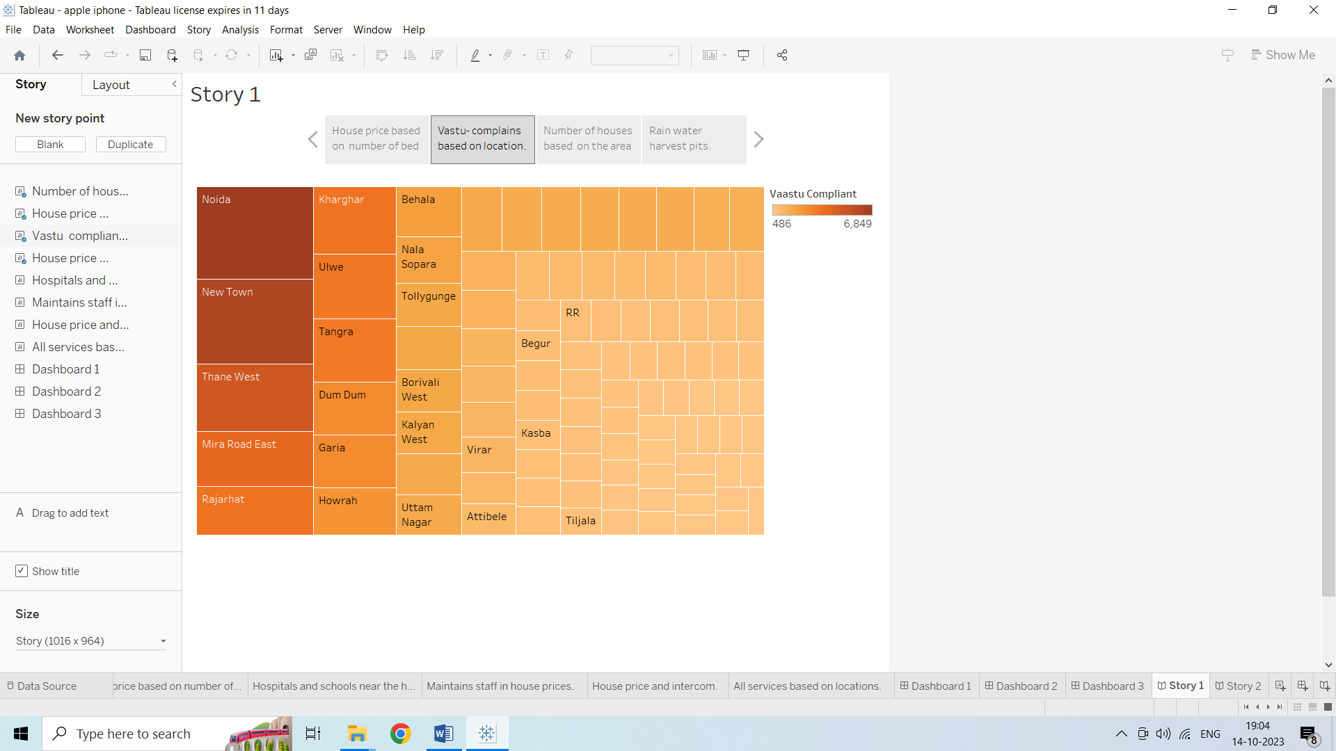

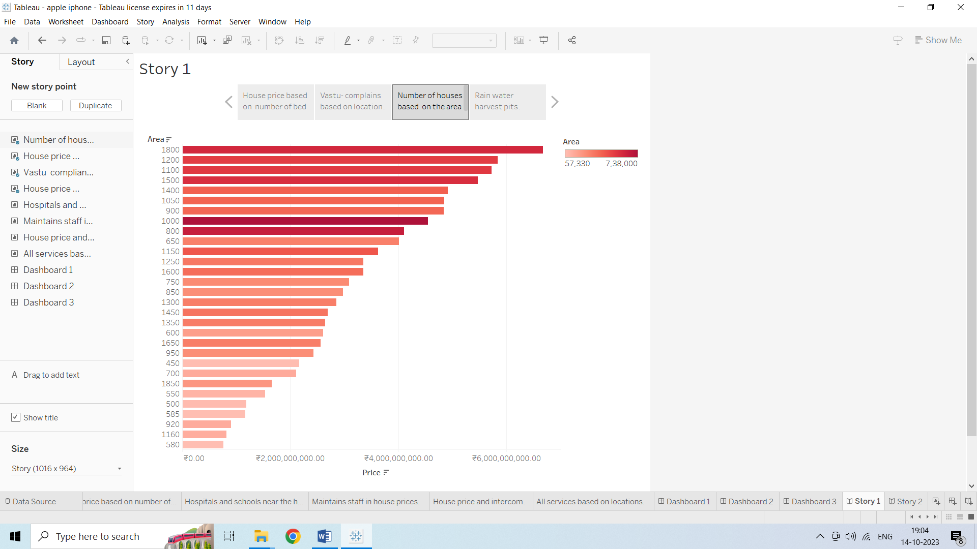

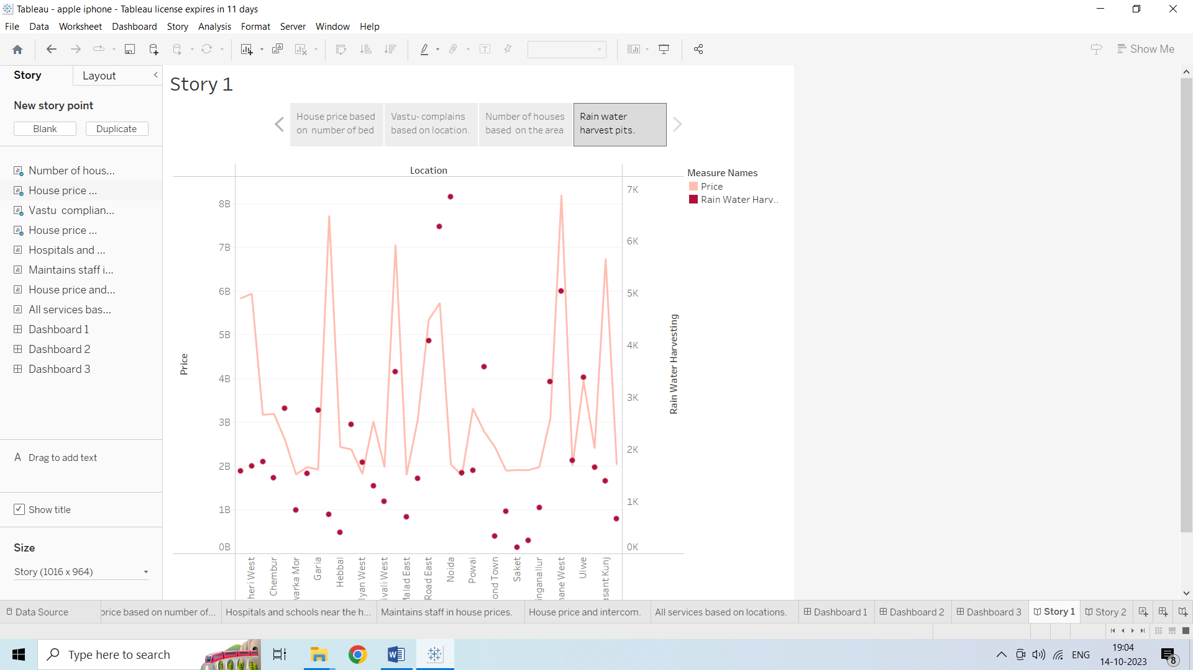

**Story 2**

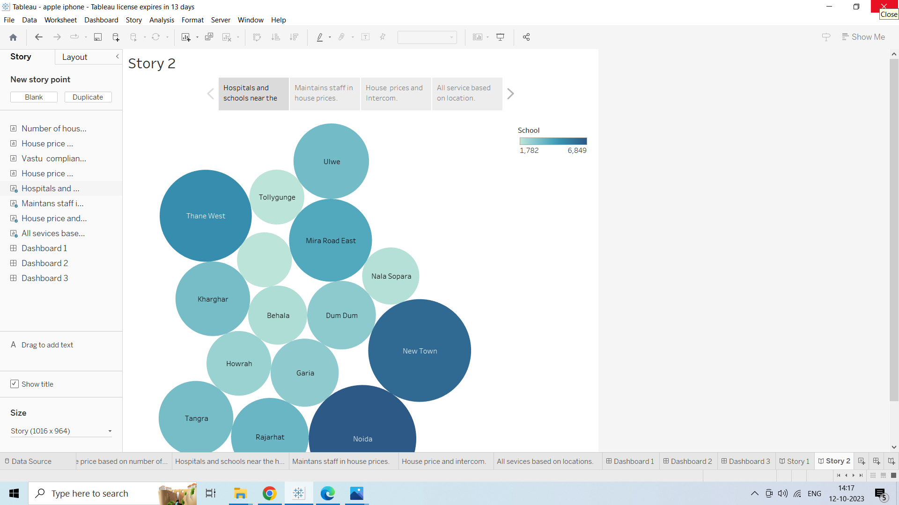

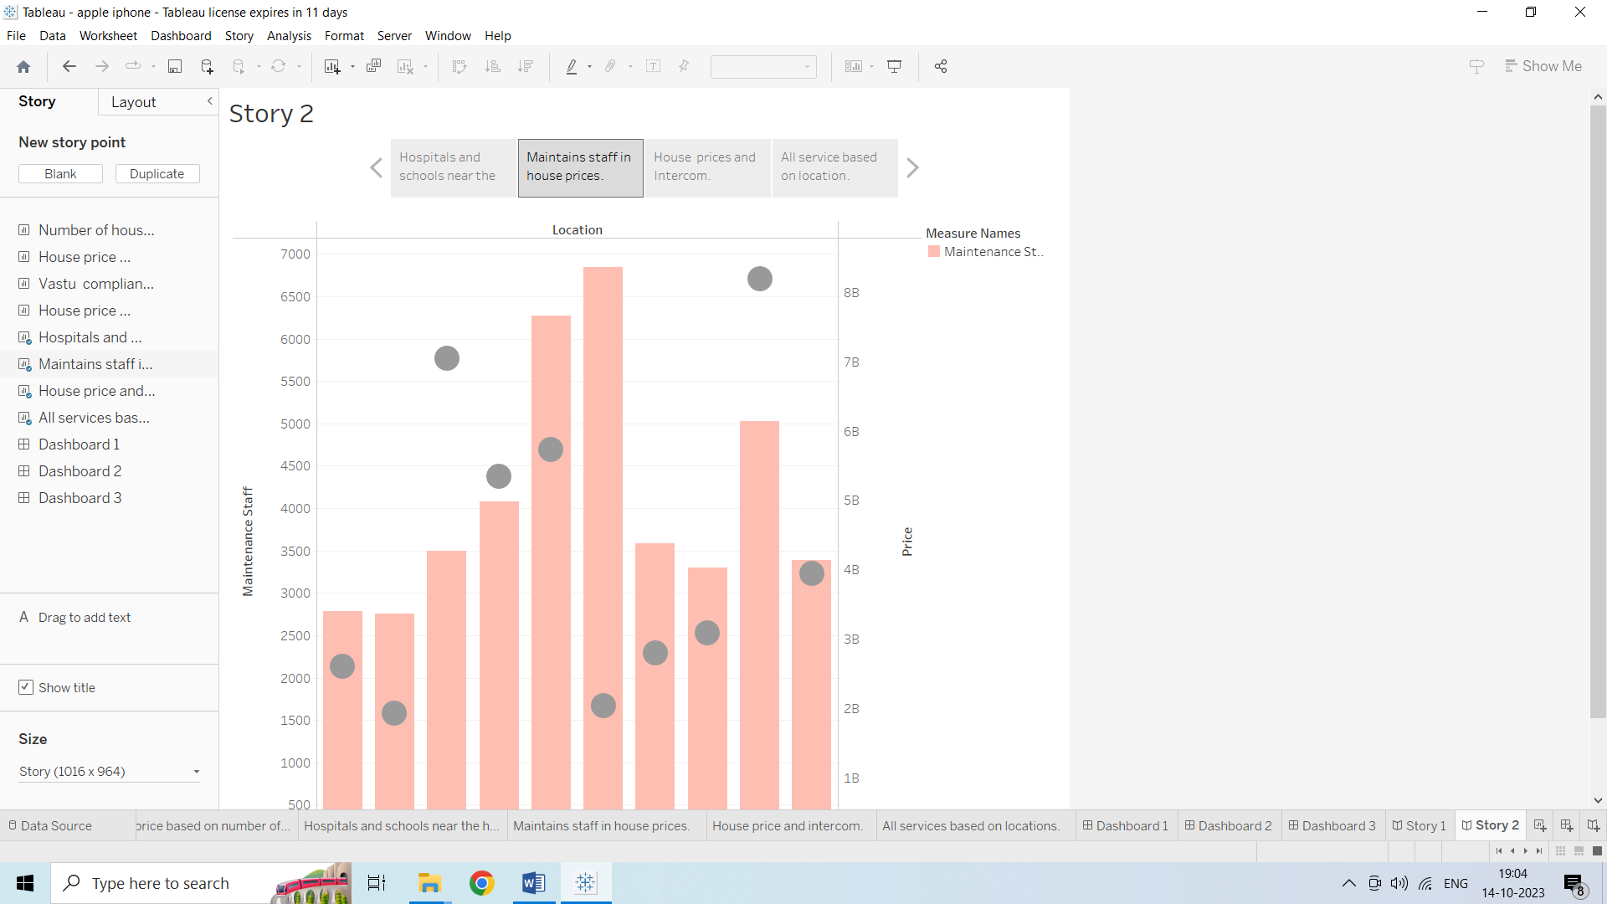

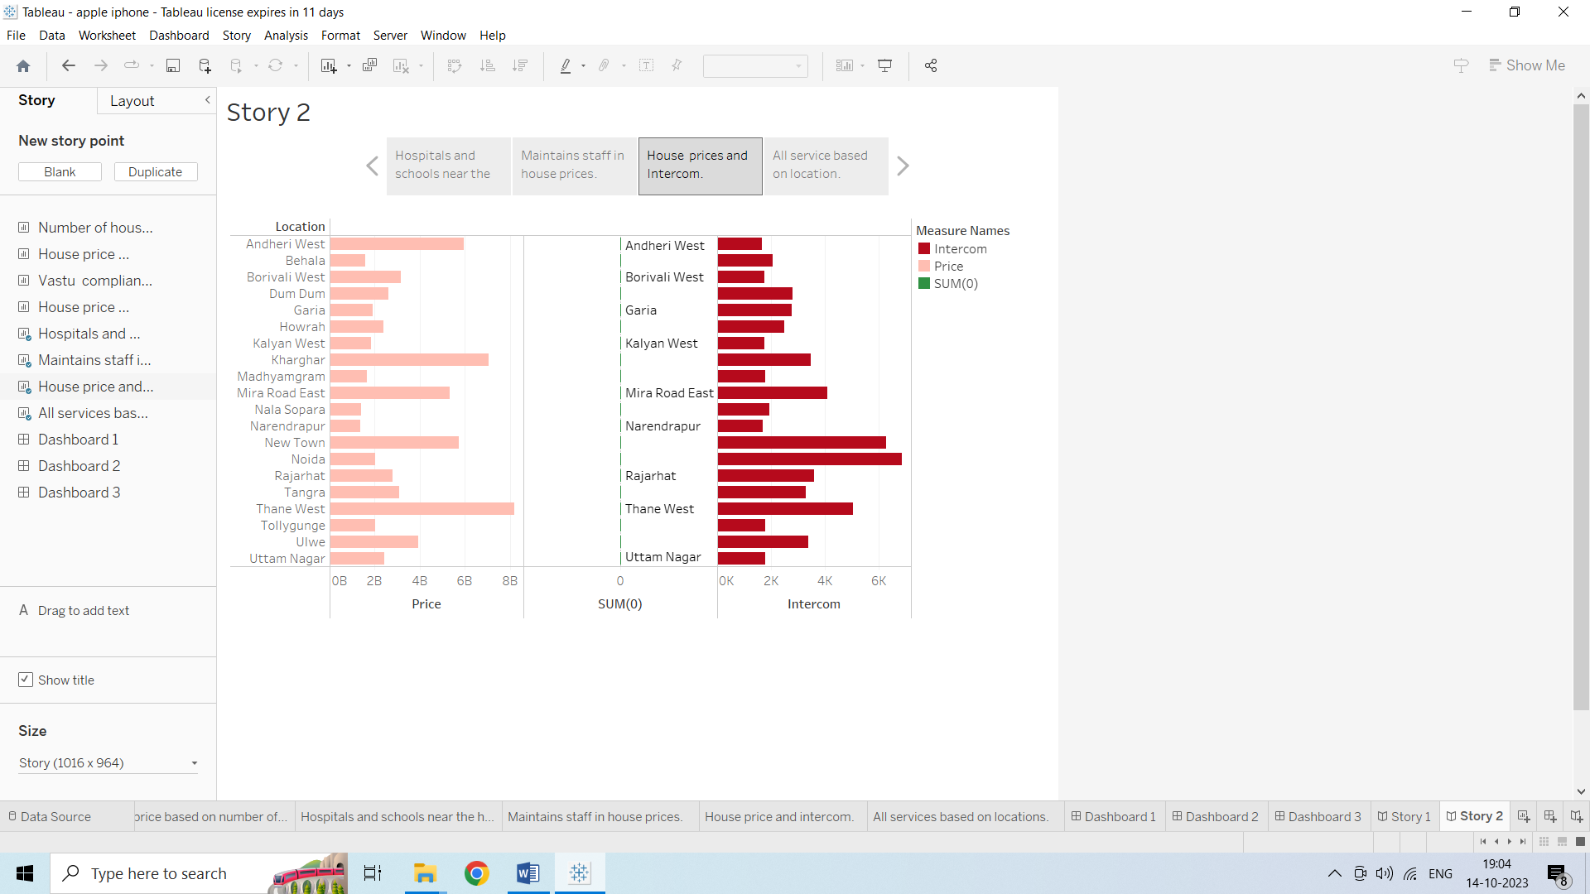

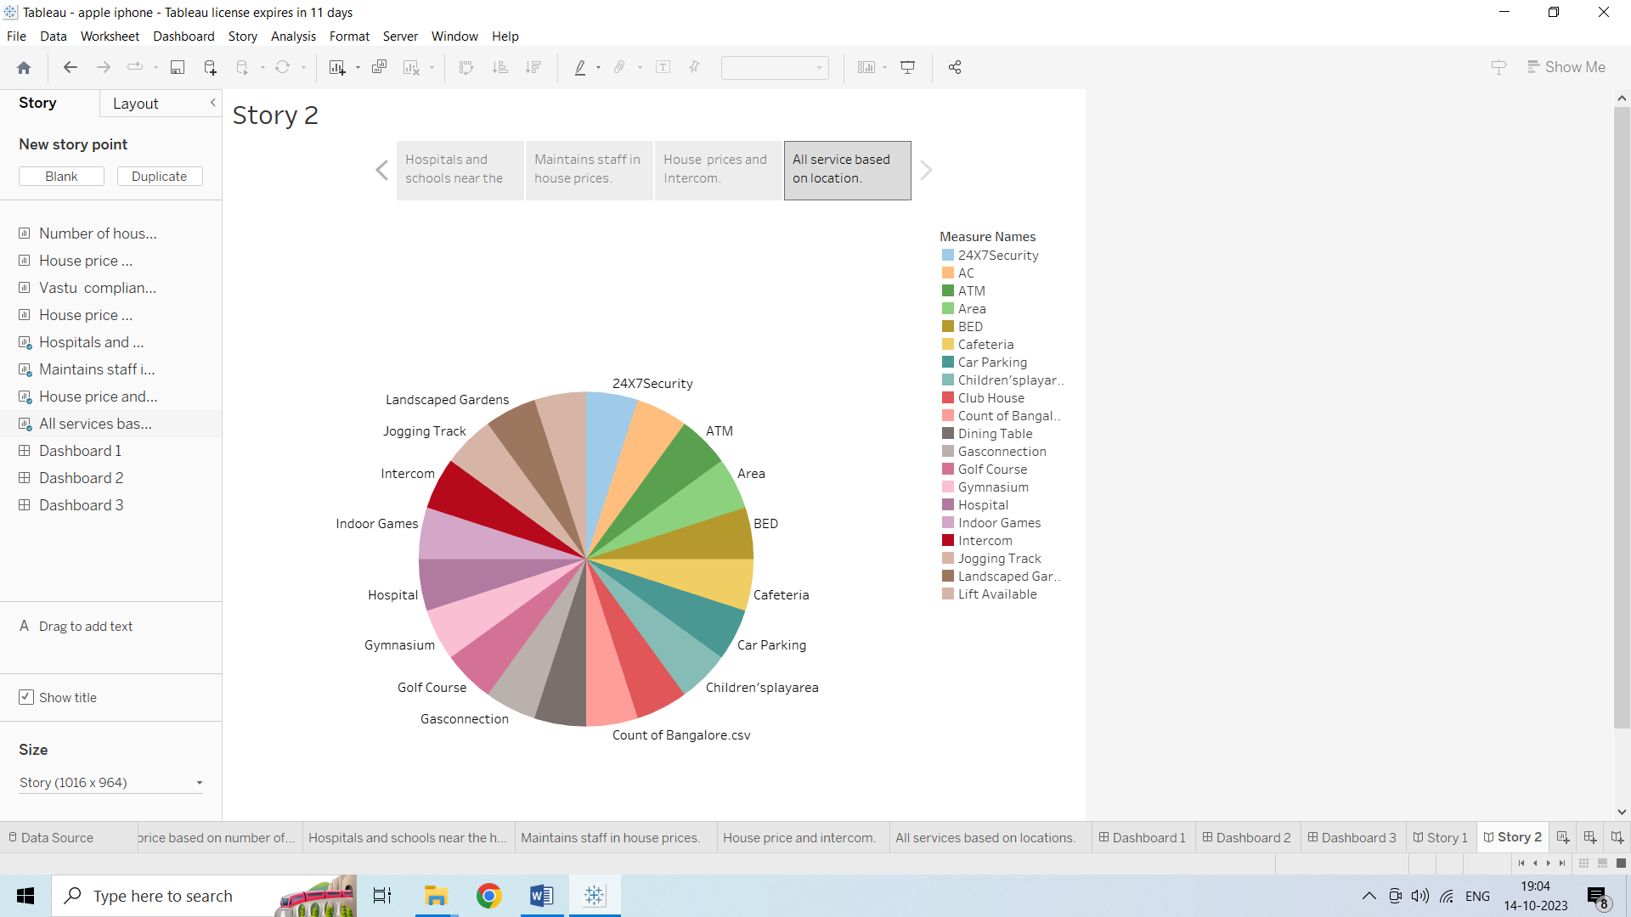

1. **Advantages of Renting and Owning**

**RENTING:**

* **Limited financial obligation.**
* **Limited maintenance expense.**
* **More liquidity.**
* **More mobility**

**OWNING:**

* **Stores of value and possible equity growth.**
* **Lifestyle choices.**
* **Decorating / renovating choices.**
* **Pride of ownership.**
* **Tax deduction for mortgage interest.**
* **More predication housing expenses.**
* **Regular analysis of housing price promotes transparency in the real estate market, reducing the likelihood of fraudulent practices.**

**Disadvantages of Renting and Owning**

**RENTING:**

* **No equity growth or store of value.**
* **Lifestyle limitations ( eg : pets ,smoking ).**
* **Decorating /renovating limitations.**
* **Less predictable housing expenses.**

**OWNING:**

* **Substantial financial obligation.**
* **Significant annual expenses.**
* **Less liquidity.**
* **Less mobility.**
* **Rapid prices increases can lead to gentrification, pushing out lower income residents from desirable neighbourhoods.**

1. **CONCLUSION**

**ln conclusion, the analysis of housing prices in metropolitan areas serves as a**

**multifunctional tool with wide ranging applications. It plays a pivot role in**

**shaping urban landscapes, economic development, and individual choices, while**

**also serving as a critical resource for policymakers and researchers.**

**Urban cities have long been a popular choice for those looking to purchase property.**

**With their convenient locations, diverse housing options, and strong investment potential,**

**urban cities have much to offer. However, as with any investment, it’s important to consider**

**the pros and cons before making a decision.**

1. **FUTURE SCOPE**

**These enhancement can help make housing price analysis more accurate, relevant, and**

**beneficial for a broader range of stakeholders, ultimately contributing to more informed**

**decision making, equitable urban development and sustainable housing solutions in**

**metropolitan area. In the future, several enhancements and improvements can be made**

**in the effective. Some potential enhancements include, Advanced Data Sources, Machine**

**Learning and AI, Real Time Data, Predictive Analytics, Visualization Tools, Integration with**

**Other Data, Affordability Metrics, Mobile Apps.**